EXPERIMENT NO : 04
Aim

1. HTML File — index.html
<!DOCTYPE html>
<html lang="en">
<head>
<meta charset="UTF-8">
<meta name="viewport"
content="width=device-width, initial-scale=1.0">
<title>Sikkim Institute of Science and Technology</title>
<!-- External CSS -->
<link rel="stylesheet" href="style.css">
</head>
<body>
<!-- Header -->
<header>
<h1>Sikkim Institute of Science and Technology</h1>
<p>Knowledge • Innovation • Excellence</p>
</header>
<!-- Navigation Bar -->
<nav>
<a href="#home">Home</a>
<a href="#about">About</a>
<a href="#courses">Courses</a>
<a href="#contact">Contact</a>
</nav>
<!-- Hero Section -->
<section id="home" class="hero">
<h2>Welcome to Our College</h2>
<p>
Empowering students through quality education, technology and innovation.
</p>
<a href="#courses" class="hero-button">
Explore Courses
</a>
</section>
<!-- About Section -->
<section id="about" class="about">
<h2>About Our College</h2>
<p>
Sikkim Institute of Science and Technology is committed to providing quality technical education and developing skilled professionals. The institution encourages innovation, practical learning and academic excellence.
</p>
</section>
<!-- Courses Section -->
<section id="courses">
<h2>Our Courses</h2>
<div class="course-container">

<!-- Course Card 1 -->
<div class="course-card">
<h3>Computer Engineering</h3>
<p>
Learn programming, computer networks, databases, software development and modern computing technologies.
</p>
</div>
<!-- Course Card 2 -->
<div class="course-card">
<h3>Information Technology</h3>
<p>
Study web technologies, information systems,
networking, databases and IT applications.
</p>
</div>
<!-- Course Card 3 -->
<div class="course-card">
<h3>Electronics Engineering</h3>
<p>
Explore electronics, communication systems,
embedded systems and modern technology.
</p>
</div>
</div>
</section>
<!-- Contact Section -->
<section id="contact" class="contact">
<h2>Contact Us</h2>
<p>
Email: info@college.edu
</p>
<p>
Phone: +91 9876543210
</p>
<p>
Address: Sikkim, India
</p>
</section>
<!-- Footer -->
<footer>
<p>© 2026 Sikkim Institute of Science and Technology.
All Rights Reserved.
</p>
</footer>
</body>
</html>

2. External CSS File — style.css
* {
box-sizing: border-box;
}
body {
margin: 0;
font-family: Arial, sans-serif;
background-color: #f4f8fc;
color: #333;
}
/* Header */
header {
background-color: #003366;
color: white;
text-align: center;
padding: 30px 20px;
}
header h1 {
margin: 0 0 10px;
}
header p {
margin: 0;
}
/* Navigation Bar */
nav {
display: flex;
justify-content: center;
gap: 30px;
background-color: #222;
padding: 15px;
}
nav a {
color: white;
text-decoration: none;
font-size: 17px;
padding: 8px 15px;
border-radius: 5px;
}
/* Navigation Hover Effect */
nav a:hover {
background-color: #0077cc;
color: white;
}
/* Hero Section */
.hero {
text-align: center;
background-color: #dceeff;
padding: 70px 20px;
margin-bottom: 30px;
}
.hero h2 {
font-size: 35px;
margin-bottom: 15px;
}
.hero p {
font-size: 18px;

margin-bottom: 30px;
}
/* Hero Button */
.hero-button {
display: inline-block;
background-color: #0077cc;
color: white;
text-decoration: none;
padding: 12px 25px;
border-radius: 8px;
}
.hero-button:hover {
background-color: #005fa3;
}
/* About Section */
.about {
max-width: 900px;
margin: 30px auto;
padding: 30px;
background-color: white;
border-radius: 10px;
text-align: center;
}
.about h2 {
color: #003366;
}
.about p {
line-height: 1.7;
}
/* Common Section Heading */
section > h2 {
text-align: center;
color: #003366;
margin-bottom: 25px;
}
/* Course Section */
#courses {
padding: 30px 40px;
}
/* Course Cards */
.course-container {
display: flex;
gap: 20px;
max-width: 1100px;
margin: auto;
}
.course-card {
flex: 1;
background-color: white;
padding: 30px;
border-radius: 10px;
text-align: center;
box-shadow: 0 2px 8px gray;
}

.course-card h3 {
color: #0077cc;
margin-bottom: 15px;
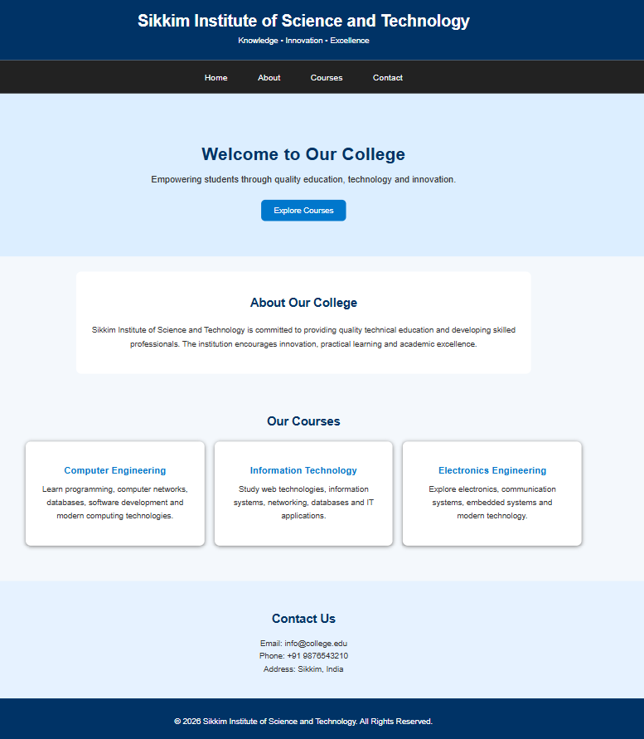
}
.course-card p {
line-height: 1.6;
}
/* Course Card Hover */
.course-card:hover {
transform: translateY(-5px);
}
/* Contact Section */
.contact {
text-align: center;
background-color: #e6f2ff;
padding: 40px;
margin-top: 40px;
}
.contact p {
margin: 8px;
}
/* Footer */
footer {
background-color: #003366;
color: white;
text-align: center;
padding: 20px;
margin-top: 0;
}
/* Responsive Design */
@media (max-width: 768px) {
nav {
flex-direction: column;
align-items: center;
gap: 5px;
}
.course-container {
flex-direction: column;
}
.hero h2 {
font-size: 28px;
}
#courses {
padding: 20px;
}
}

